**World Hepatitis Day 2025 – Let’s Break It Down**

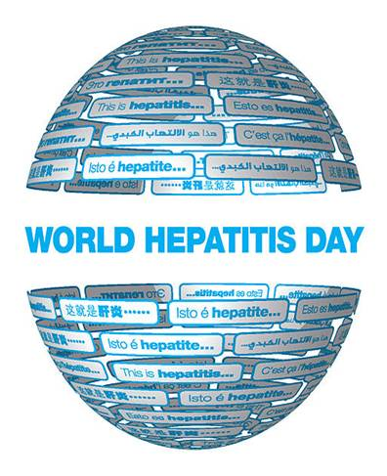

**World Hepatitis Day** is observed each year on **28 July** to raise awareness of viral hepatitis, an inflammation of the liver that causes severe liver disease and liver cancer.

**The theme for 2025: Hepatitis: Let’s Break It Down** calls for urgent action to dismantle the financial, social and systemic barriers – including stigma – that stand in the way of hepatitis elimination and liver cancer prevention.

Chronic hepatitis B and C silently cause liver damage and cancer – despite them being preventable, treatable, and, in the case of hepatitis C, curable. The theme emphasizes the need to simplify, scale up, and integrate hepatitis services – vaccination, safe injection practices, harm reduction and especially testing and treatment – into national health systems.

The campaign is a reminder that we must act now to expand access, integrate care, and end hepatitis as a public health problem by 2030.

Hepatitis, an inflammation of the liver, can cause yellowing of the whites of the eyes (sclera), a condition known as jaundice. This yellowing is due to a buildup of bilirubin, a yellow pigment that the liver normally processes. Additionally, some individuals with hepatitis, particularly hepatitis C, may experience dry eyes due to autoimmune issues or interferon-related side effects.

**How Hepatitis Affects the Eyes:**

* **Jaundice:**

The most visible eye-related symptom of hepatitis is scleral jaundice, where the whites of the eyes turn yellow. This occurs when the liver is unable to process bilirubin properly, leading to its accumulation in the body.

* **Dry Eyes:**

Hepatitis C, and sometimes other forms of hepatitis, can lead to dry eyes. This may be related to autoimmune conditions like Sjögren's syndrome that can coexist with hepatitis C.

* **Other potential, but less common, effects:**

Hepatitis can also be associated with other ocular complications, such as subconjunctival hemorrhages (small, red spots on the sclera), retinal vasculitis, and third nerve palsy.

Specific Types of Hepatitis and Eye Symptoms:

* **Hepatitis A:** Jaundice is a common symptom.
* **Hepatitis B and C:** These can cause chronic liver damage, which can lead to jaundice and other eye complications like dry eyes.

**When to Seek Medical Advice:**

* If you notice yellowing of the eyes or any other vision changes, especially in the presence of other hepatitis symptoms like fatigue, nausea, or abdominal pain, it's crucial to consult a healthcare professional.
* Early diagnosis and treatment of hepatitis can help prevent or minimize potential long-term complications, including those affecting the eyes.