WORLD DISABILITY DAY

Saturday, 3 December 2022 is the International Day of Persons with Disabilities (IDPD). First proclaimed in 1992 by the United Nations General Assembly resolution, the day aims to promote an understanding of disability issues and mobilise support for the dignity, rights and well-being of persons with disabilities.
The day is about promoting the rights and well-being of persons with disabilities at every level of society and development, and to raise awareness of the situation of persons with disabilities in all aspects of political, social, economic, and cultural life.
Helen Keller is one of the most well known figures of the 20th century who inspired future generations of those with disabilities to live their lives to the fullest. When she was just 19 months old, Keller lost her sight and hearing as a result of an illness, which is thought to have been either rubella or scarlet fever. But with the help of her teacher, Anne Sullivan, Helen Keller learned to spell and went on to become a famous author, composing nearly 500 speeches and essays on a wide variety of topics. She was the first dead blind person to earn a Bachelor of Arts.

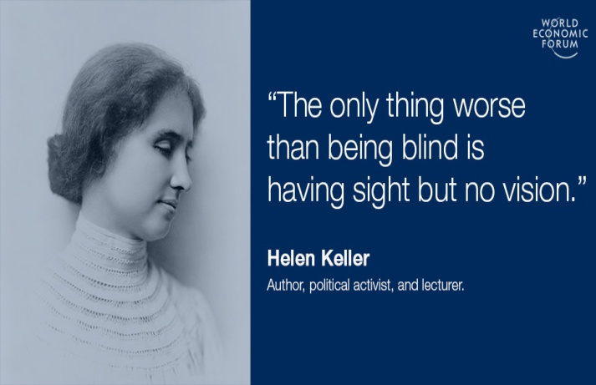

The number of different vision conditions that can affect a person's eyesight are varied in the way they do affect the person's daily life. Some of these conditions have a minor effect, while others may have a much larger effect.
Visual impairment (vision impairment, vision disability) is defined as a decreased ability to see to a degree that causes problems not fixable by usual means, such as glasses or medication. Visual impairment can be due to disease, trauma, or congenital or degenerative conditions. The terms "partially sighted", "low vision", "legally blind" and "totally blind" are used by schools, colleges, and other educational institutions to describe students with visual impairments.
Eye disorders which can lead to visual impairments can include retinal degeneration, albinism, cataracts, glaucoma, muscular concerns that result in visual disturbances, corneal disorders, diabetic retinopathy, congenital disorders, and infection. Visual impairment can also be caused by brain and nerve disorders, in which case it is usually termed cortical visual impairment (CVI). Various conditions require only eyeglasses or contact lenses to correct the person's vision. Other conditions may require surgery.

Vision Conditions
There are a number of eye problems and conditions that may make it more difficult for a person to see things clearly, yet do not cause loss of vision. An example of this is, 'Myopia,' or, 'Nearsightedness,' where a person sees nearby objects clearly, but has difficulty focusing on objects that are more distant.
'Hyperopia,' or, 'Far-sightedness,' is another example of a vision condition; this one involves the ability to see distant objects clearly, with difficulty focusing on nearby objects.
A third example of an eye condition that does not cause loss of vision is, 'Astigmatism,' where the person's vision appears blurred at any distance. These conditions are common and can often be corrected with eyeglasses or contact lenses.

Low Vision
The term, 'Low Vision,' sometimes also referred to as, 'Vision Loss,' means that even though a person may use eyeglasses, contact lenses, medication, or surgical techniques to improve their vision; they still have difficulty in seeing.
Most persons develop low vision due to eye diseases or health conditions.
'Diabetic Retinopathy,' is a condition in which Diabetes has damaged tiny blood vessels inside the person's retina, causing low vision.

- 'Age-Related Macular Degeneration,' is a condition in which the cells in a person's retina that allow them to see fine details have died.

- 'Glaucoma,' is a condition in which the fluid pressure in a person's eyes slowly rises, damaging their optic nerve.

- 'Cataracts,' are a condition that involves a clouding of the lens in a person's eye.
Receiving prompt treatment for these conditions may prevent them from getting worse, making regular eye exams crucial.
Cataracts
As many as 10 million people around the world suffer from cataracts. In Germany alone, more than 600,000 cataract operations are performed each year.
Cataracts can be either congenital or acquired; age-related opacification of the lens is the most common type. The main symptom of cataract is slowly progressive worsening of vision, but glare disability and nearsightedness can also be signs of the disease.
Cataract operations are now usually performed on an outpatient basis. The eye is anesthetized, pretreated with antibiotics, and surgically opened. New approaches permit the operation to be performed through an incision smaller than 2 mm.
In the phacoemulsification technique, the lens is emulsified and aspirated away through a vibrating hollow needle. The surgeon then implants an intraocular artificial lens. Patients without any other diseases of the eye can achieve a visual acuity of 1.0 or even better. Special optical designs for the artificial lens can further optimize the quality of vision and thereby improve patient satisfaction.

Vision Terms
According to the International Classification of Diseases, There are 4 levels of visual function:
- Blindness
- Normal vision
- Severe visual impairment
- Moderate visual impairment
Moderate visual impairment combined with severe visual impairment are grouped under the term low vision: low vision taken together with blindness represents all visual impairment.
There are some different terms used to describe levels of vision disability. These terms include, 'Partially Sighted,' 'Low-Vision,' 'Legally Blind,', and 'Totally Blind.'
- Partially Sighted means the person has some form of visual disability that may require special education.

- Low-Vision is usually used to refer to persons who experience a more severe loss of vision that is not necessarily limited to distance vision. Persons with low-vision may be unable to read a newspaper at an average distance with eyeglasses or contacts, and may need large print or Braille.

- Persons who are legally blind have less than 20/200 vision in their better eye, or a very limited field of vision, often 20 degrees at its widest point.

- Persons who are totally blind are unable to see and often use Braille or other non-visual forms of media.
Eye disorders lead to vision loss; visual impairment is a consequence of a functional loss of vision rather than the eye disorder itself. Retinal degeneration, muscular problems, albinism, corneal disorders, congenital disorders, and infections can also lead to vision impairment.

Color Blindness
Approximately one in twelve men, and one out of every two-hundred women, experience a form of colorblindness. One misconception that many people have is that persons with colorblindness see only black and white. In actuality, there are many types and degrees of colorblindness.
- Monochromacy is the form most associated with colorblindness, where people see no colors.
- Protanomaly is referred to as, 'red-weakness,' and the person views a shift in the hue of red colors towards green and additional effects.
- Deuteranomaly is also referred to as, 'green-weakness,' and the person has difficulty telling differences in the red, orange, yellow, and green regions of the color spectrum.
- Persons with Dichromacy cannot tell the difference between red, orange, yellow, and green.
- Persons with Protanopia find that the brightness of colors such as red, orange, and yellow is greatly reduced; they may appear as black or dark gray.
- Persons with Deuteranopia experience the same vision issues as persons with Protanopia, but the dimming is not as great.

Vision Loss Facts and Statistics
- Over 90% of vision loss could be avoided.
- 55% of people with vision loss are women.
- 73% of people with vision loss are over 50 years old.
- Poor eye health leads to an increased risk (up to 2.6 times) of mortality.
- Over 90% of those with vision loss live in low and middle-income countries.
- Unaddressed poor vision results in a global economic productivity loss of $411 Billion each year.
- 1.1 billion People experience vision loss, primarily because they do not have access to eye care services.
- Children with vision impairment are up to 5 times less likely to be in formal education and often achieve poorer outcomes.
- The number of people with vision loss will rise from 1.1 billion to 1.7 billion people by 2050, mainly due to population growth and population aging.
- Eye care needs are expected to increase substantially; projections estimate half of the global population (4.8 billion) will need access to regular eye care services to prevent/treat sight loss by 2050.
Leading Causes of Vision Loss Include:
- Un-operated cataracts, responsible for vision loss in 100 million people.
- Uncorrected refractive error, which is responsible for distance vision loss in 161 million people and near vision loss in an additional 510 million people.
- Age-related macular degeneration (AMD), glaucoma and diabetic retinopathy accounting for 8.1 million, 7.8 million and 4.4 million people with vision loss respectively.
- 56 million people have other cause of vision loss.
Vision Facts (WHO):
- 80% of all visual impairment can be prevented or cured.
- 82% of people living with blindness are aged 50 and above.
- About 90% of the world's visually impaired live in low-income settings.
- 285 million people are estimated to be visually impaired worldwide: 39 million are blind and 246 have low vision.
- The number of people visually impaired from infectious diseases has reduced in the last 20 years, according to global estimates work.
- Globally, uncorrected refractive errors are the main cause of moderate and severe visual impairment; cataracts remain the leading cause of blindness in middle and low-income countries.

