HEPATITIS AND YOUR EYES
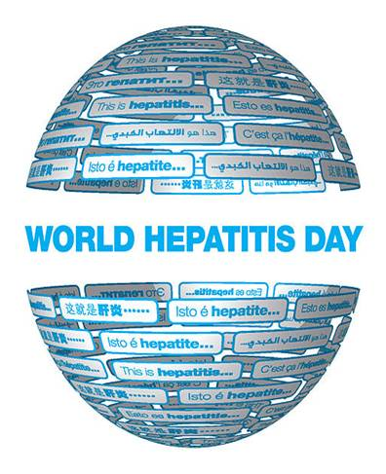

World Hepatitis Day (WHD) takes places every year on 28 July bringing the world together under a single theme to raise awareness of the global burden of viral hepatitis and to influence real change. In 2022 the theme is ‘I Can’t Wait’.
On World Hepatitis Day, 28 July, we call on people from across the world to take action and raise awareness of hepatitis because Hepatitis Can’t Wait.

Hepatitis is a condition that involves inflammation of the liver.

According to the WHO, hepatitis viruses are the most common cause of the disease. Autoimmune conditions and toxic substances can also lead to some forms of hepatitis.

Although hepatitis affects the liver, it can also cause problems with other organs and additional complications. It might be surprising to learn that hepatitis can even affect the eyes.

Common Forms of Hepatitis

Although there are five main types of hepatitis, three forms of the disease are the most common:
- Hepatitis A: Hepatitis A is typically contracted by eating or drinking contaminated food or water. There is a vaccine to prevent hepatitis A.
- Hepatitis B: Hepatitis B is contracted through infected blood, semen, and vaginal secretions. It is usually transmitted through needle sharing, sexual contact, and from mother to baby during birth. Hepatitis B vaccines are also available.

- Hepatitis C: Hepatitis C is usually transmitted through blood infected with the hepatitis C virus. Although less common, transmission is also possible through sexual contact. Currently, no vaccine protects against hepatitis C.
​

Ways Hepatitis Can Affect the Eyes
Different forms of hepatitis can have an effect on the eyes and vision. In some cases, it is the disease itself that affects the eyes. In other instances, the medication used to treat hepatitis may have side effects that affect vision. The most common ways hepatitis affects the eyes include:
Yellowing of the Whites of the Eyes
Hepatitis damages the liver. If the liver does not function efficiently, it cannot excrete bilirubin, which is produced by the breakdown of red blood cells. Bilirubin can build up in the body, which often results in yellowing of the whites of the eyes and the skin. The yellowing is temporary and usually resolves after bilirubin levels return to normal.
Dry Eyes
Dry eyes are a common eye complication that can occur with hepatitis C. There is a correlation between dry eyes and hepatitis C infection. Exactly why the condition develops in people with hepatitis C is not fully understood.
Interferon-Associated Retinopathy
Some medications used to treat hepatitis B and C contain interferons. Interferons are a family of proteins that can boost the immune system and fight hepatitis B and C viruses. Retinopathy is a potential side effect of medications containing interferons.
Retinopathy involves swelling or leaking of the blood vessels in the retina. Interferon-associated retinopathy is usually mild and can be reversed. However, retinopathy is a serious eye condition that can lead to vision loss, so it’s essential to be aware of the condition. Symptoms of interferon-associated retinopathy include dark spots in the field of vision, blurry vision, and floaters.
Although not specifically caused by the hepatitis virus, there are also possible eye complications that can occur after an infectious disease such as hepatitis, including:
Retinal Vasculitis
Retinal vasculitis involves inflammation of the retinal blood vessels. The condition can develop after an infectious disease such as hepatitis due to the immune system response. Symptoms of retinal vasculitis include blurry vision and seeing floaters or white spots.
Third Nerve Palsy
Third nerve palsy involves temporary paralysis of the cranial nerve, which controls eye muscle movement. It can be caused by an infection and has been associated with hepatitis B infection. Symptoms of third nerve palsy include an inability to move the eye up or down or to rotate the eye. Some people that develop third nerve palsy also experience a change in pupil size.
​

Treatment & Protecting Your Eyes from Hepatitis & Infectious Disease
Some forms of hepatitis, such as hepatitis A, may not require treatment. Hepatitis B and C may be treated with interferon or other antiviral medications. In either case, abstaining from alcohol is essential for people with hepatitis.
Treatment for eye conditions that occur due to hepatitis may vary. For example, eye drops or artificial tears may ease discomfort caused by dry eyes. In some cases, such as third nerve palsy, there is no treatment.
New medications for treating hepatitis are awaiting FDA approval. Certain medications recently approved are very expensive, which may limit treatment options for some people.
It’s essential for people with hepatitis to talk with their doctor to determine the best course of action. In some cases, promptly treating hepatitis may prevent eye complications. People that are diagnosed with any form of hepatitis should get a comprehensive vision exam before they start treatment and at regular intervals recommended by their eye doctor.
If you are going to be taking an interferon-type medication, talk to your eye doctor to determine if you need more frequent eye exams or if you should follow any special instructions. Getting a baseline eye exam will allow your eye doctor to determine if the hepatitis virus or treatment causes any eye changes and monitor their severity and need for treatment.
Hepatitis is a common infection that can affect more than the liver. To protect your eyes, it’s vital to have regular eye exams.

